Pocket Knife Design and Modeling
Zach Schirado
ME421 CATIA Spring 2020
Large Tanto Blade
Large Wharncliffe Blade
Project Description
The goal of this project was to model a custom designed friction folder pocketknife, using design tables to allow for different blade shapes and sizes. The final product includes two blade shapes and two overall sizes, resulting in 4 different available configurations. The knife has options for a 4-inch and 2.5-inch blade length, and a Wharncliffe or American Tanto style blade. The design tables and dimensioning are set up to allow for more flexibility in size by changing the values for blade and handle dimensions. The formulas used to define part dimensions should allow for the scaling of the knife based on the desired overall length, height, and thickness of the knife defined in the design tables.

Handle
Using rough dimensions from a production folding knife, I started by modeling the profile of the handle in the sketcher workbench. The intent was to make an integral handle, meaning it is made from a single piece of material without the need for fasteners (standoffs or backspacers) to connect the two scales. The first sketch and pad defined the maximum overall dimensions of the handle. These dimensions were set using the design table as they are the most fundamental dimensions of the handle. From here, I added a pocket to accommodate the blade, and a fillet at the end of the handle and inside pocket to keep the thickness uniform and allow for a more comfortable grip. Like all non-design table dimensions, the inside pocket was first manually dimensioned based on my preferences, then defined using formulas that kept dimensions the same while allowing for scaling. This allowed me to experiment with the design before finding and setting ratios.

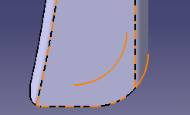

Next, a sketch was drawn in order to create contouring at the front of the handle. Two circles were used to create the profile. Circles were used as I found that scaling and defining splines with formulas was much more difficult while offering little benefit. The larger curve was meant to allow for more grip on the knife, while the smaller curve at the top of the handle is meant to allow for a forward grip on the blade. This makes it less likely the knife closes in use as there is no lock. Like previous dimensions, these were first set manually and then defined using formulas with respect to the design table dimensions. By this point, the smaller design table dimensions were set, allowing me to switch back and forth between handle sizes to ensure design features translated properly between sizes. Doing this as I added features instead of at the end allowed for an easier troubleshooting process.

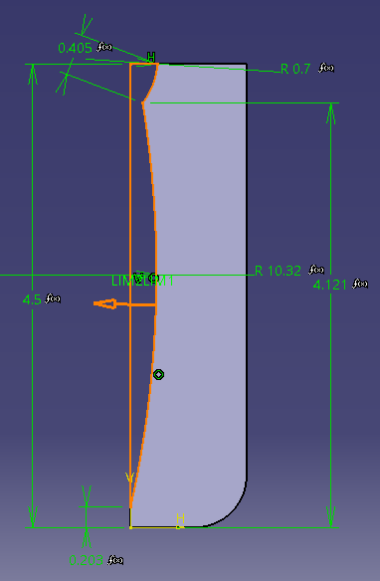

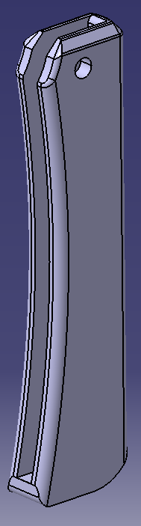
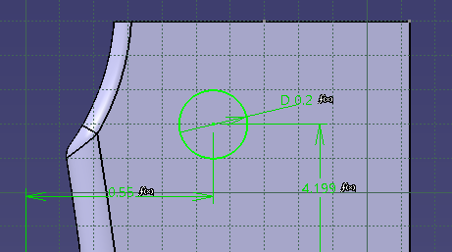
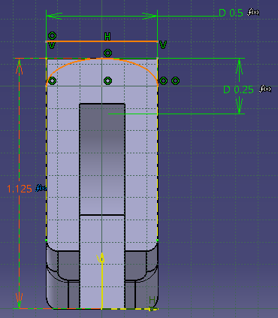
With the general shape of the handle outlined modeled, smaller features like chamfers and fillets were added to create a more aesthetically pleasing design, and a more comfortable grip. Like all the non-design table dimensions, the fillet and chamfer dimensions were set with formulas to ensure proper scaling between handle sizes. A profile was also cut from the back of the handle with the pocket tool, as the exact look I wanted could not be obtained with a fillet. The dimensions for this pocket were set with partly with formulas, but also with respect to the projection of the top of the handle. This made it possible to scale the pocket without the need for formulas on every dimension, as the projection dimensions change along with the handle. To finish off the handle, a pivot hole was added. The position and diameter of the hole were set with formulas based on the overall handle length.

Blade
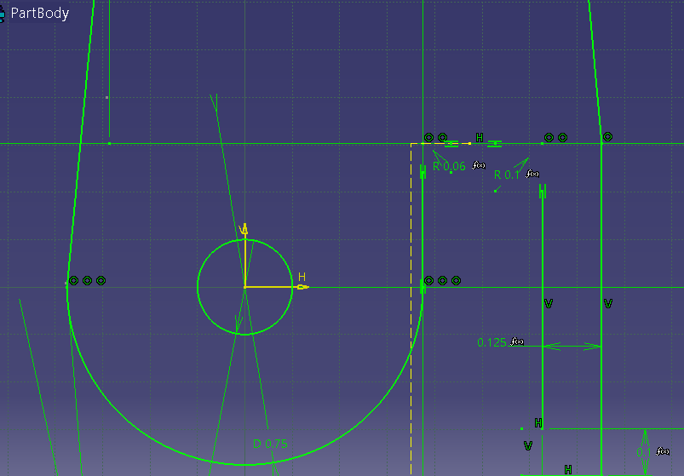
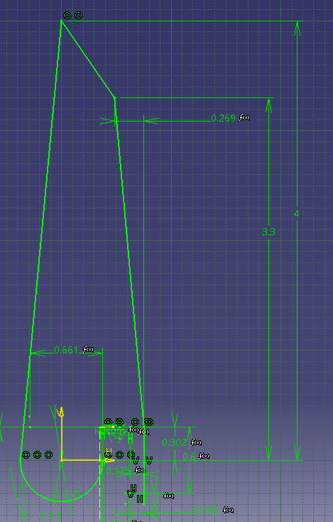
With the handle complete, the maximum dimensions of the blade could be derived. Dimensions were taken from the handle to find the pivot dimensions, blade tang dimensions, and spacing required between the pivot and blade tang for clearance when opening and closing the knife. The maximum blade length was also found using the inside pocket dimensions. As the knife has no lock, the open and closed positions are set when the tang contacts the outside of the handle and when the blade contacts the inside of the handle (this necessitates the use of a soft handle material, such as wood, to avoid dulling the blade). The overall profile of the blade was sketched out and padded based on measurements taken of the handle. The dimensions were not set using formulas at this point as they still needed tweaking. I placed the profile of the blade in an assembly with the handle and used the manipulate tool and stop manipulate on contact setting to see how the blade interacted with the handle. The blade tang and pivot dimensions both needed tweaking to allow the blade its full range of motion. Once I was sure the blade could open, close, and stopped properly at the open and closed positions, I set the pivot and blade length dimensions using a design table to allow scaling. The blade stock thickness was also set this way. The rest of the dimensions were then set using formulas based on the design table dimensions. More tweaking was needed at this point to ensure the large and small blades interacted properly with the handle. Once I was happy with the blade profile, I added smaller features and a blade grind, along with an alternate blade shape.

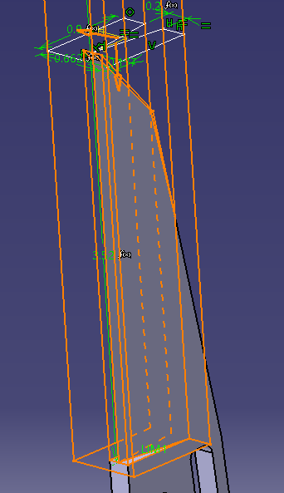
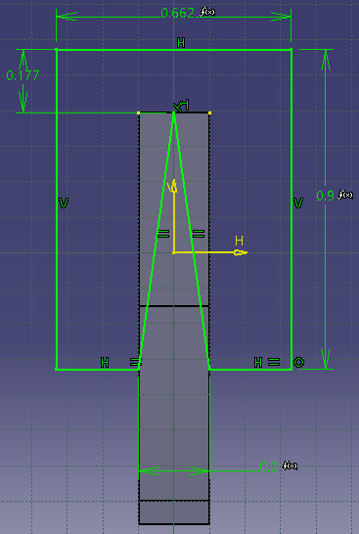
The blade grind was achieved using a pocket. I created a plane at the tip of the knife, perpendicular to the edge. The desired grind angle was sketched on this plane, with respect to the projected profile of the edge of the knife. This ensured the point created by the pocket was always coincident with the edge of the blade stock. The rest of the dimensions were set relative to the blade length using formulas. At this point I was also checking the grind scaled properly between the large and small blades. The depth of the pocket was set relative to the tip of the blade, and with respect to the overall blade length using a formula. This ensured the grind stopped at the same point on both the large and small blades.

Next, I started on creating a new blade shape. The initial Wharncliffe style blade is good for draw cuts and utility tasks, so I decided the alternate blade shape should be more suited to piercing and prying tasks. The American Tanto blade does both of these better than a Wharncliffe, while keeping the overall size of the blade relatively similar. I added a new value to the design table that allowed me to change the front and back blade lengths independently. This let me create a secondary edge for the tanto blade without the need for a new sketch or feature by shortening the front length and extending the back length. A second bevel needed to be made on this edge, as the initial linear bevel left the tanto edge unsharpened as shown.
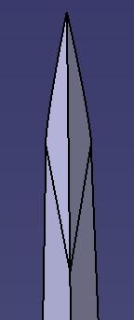
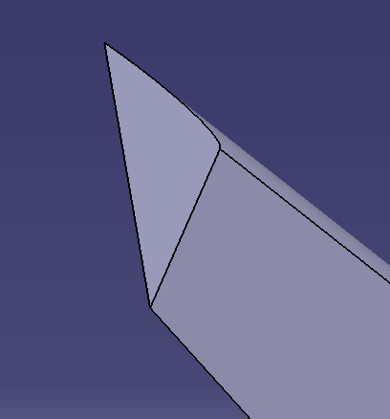
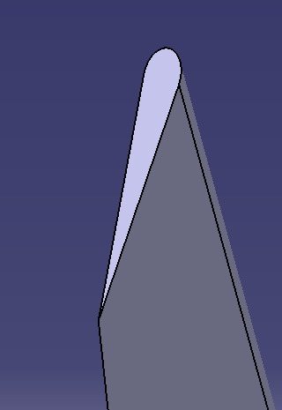
The bevel on this edge was created in the same fashion as the initial bevel. A plane was created perpendicular to the flat edge shown, and a profile was sketched and pocketed. The sketch was dimensioned with respect to the blade length using a formula. Unlike the initial bevel, this feature was only needed on the tanto version of the blade and interfered with the Wharncliffe version. I added another parameter to the design table in order to deactivate the feature on the Wharncliffe blade and reactivate it on the tanto blade.

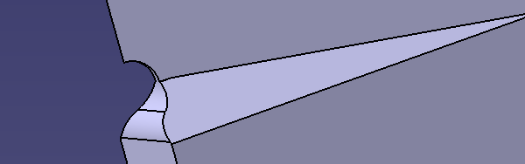
Once the grinds for both blade shapes and sizes were established, I refined the blade with smaller features. I chamfered and filleted the blade at the end of the grind towards the pivot and added a sharpening choil. The chamfer and fillet dimensions were set using a formula based on the length of the blade. The choil was created using a circular sketch and a pocket feature. The choil placement was set using the projected geometry of the blade, and the size set using a formula.

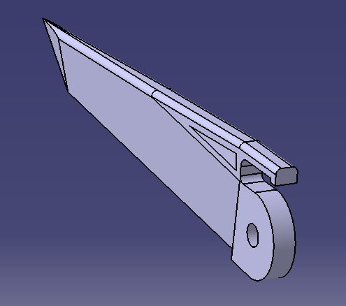
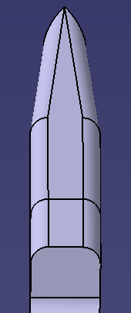
To further refine the blade, I also added a fillet to the spine. The fillet rounds the spine while retaining the full blade stock thickness. The Wharncliffe blade allowed for a full-length fillet, but the tanto blade point rounded out when the same fillet was applied. To counter this, I only applied the fillet where the stock thickness was at its maximum. The tanto point stayed sharp this way, but any sharp edges on the back of the blade were removed.

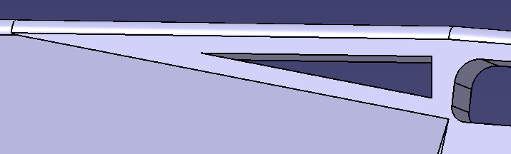
To finish the blade, a pocket was created in the flat section towards the spine. I used the Project 3D Elements tool to create a sketch that matched the lines of the blade at this point. I sketched lines parallel to each blade line and spaced them from the projected lines using a formula. I then pocketed the sketch. This feature adds an aesthetic touch to the blade while also allowing for another way to open and close the knife. With this final step, the blade in both tanto and Wharncliffe versions was complete.

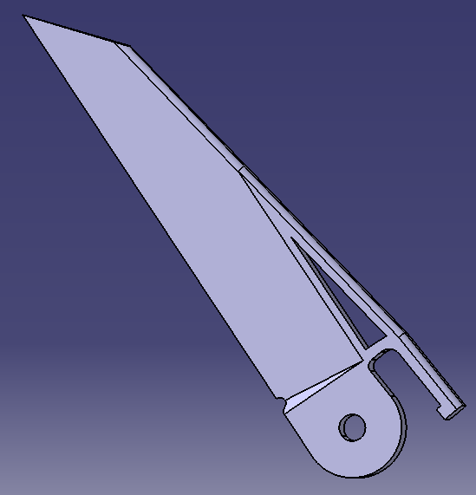
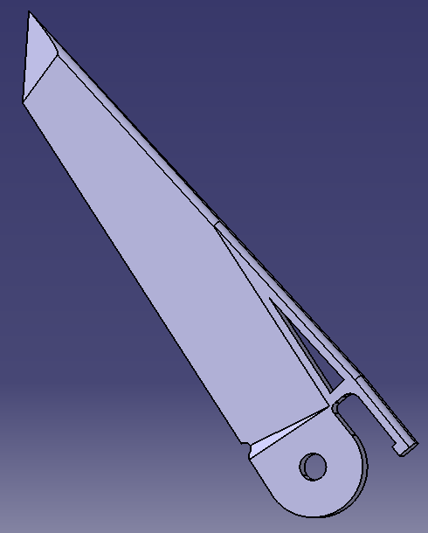

Pivot
The pivot was the easiest part to create. The center diameter and distance between the ends were both set using a design table, and the thickness of the ends set with a formula based on the design table. The pivot was made using a circular sketch and pad for the center, and a second circular sketch and pad mirrored around the center to create the ends. The ends of the pivot were chamfered for comfort and aesthetic appeal. The pivot would have to be made in two parts were the knife to be manufactured, but for the sake of simplicity it was made as a single part for this project.
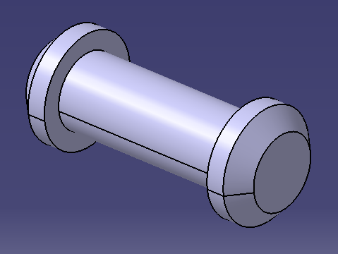

Assembly
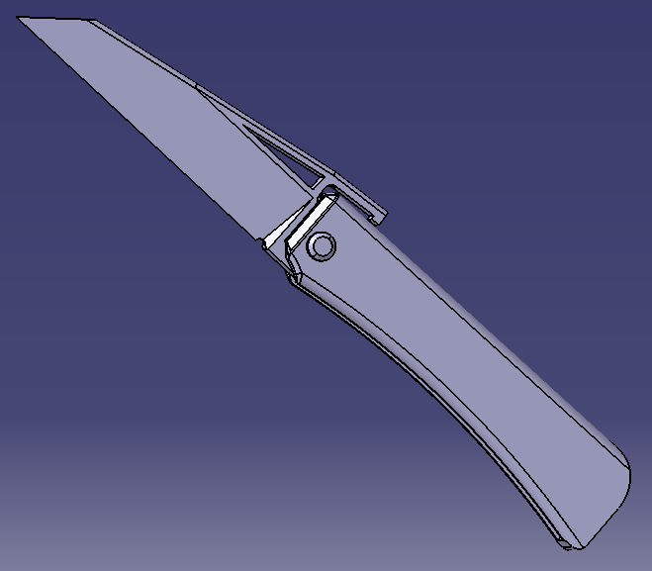
Assembly was straightforward. A coincidence mate was used between the axis of the pivot and pivot holes in both the blade and handle. The inside of the pivot was contact mated to the outside of the handle, and the outside of the blade pivot area was contact mated to the inside of the handle. The operation of the knife can be simulated using the Stop Manipulate on Clash command while manipulating the blade.

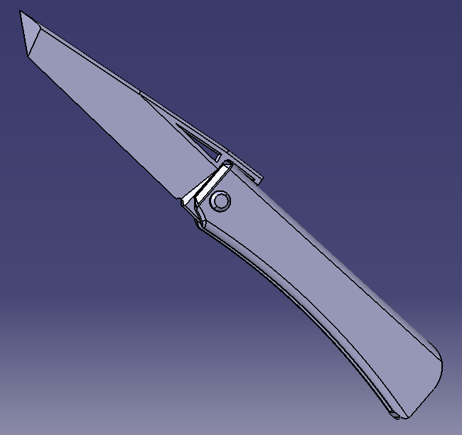

Final Product
Once the knife was assembled, I added materials to the handle, blade, and pivot. The handle being Indian Teak wood, the blade steel, and the pivot yellow brass. The soft handle material would ensure the blade is not damaged on closing and would also be an easy material to execute the integral handle design with. Final renders of the product are shown below. Only the large sizes are pictured, as without a reference they look identical to the smaller sizes.

Lessons Learned
This project taught me several lessons in using CATIA as well as in implementing a design process. The biggest learning curve came with using design tables and formulas to set dimensions. At first I did not have a clear scheme for setting dimensions, and the scaling between large and small part sizes resulted in problems that were difficult to troubleshoot. I realized that it was important to set a few baseline dimensions through the use of design tables, and then set formulas based on these baseline dimenions. This made the troubleshooting process much faster and reduced the number of scaling errors I encountered. Another lesson I learned came when I was trying to fit the blade with the handle. I kept switching between the two parts while trying to write down dimenions and adjust the blade. I realized that I could put the parts in an assembly and use the manipulate and stop maipulate on clash tools to design the blade dimensions around the handle inside of the assembly file. This made fitting the two parts together much faster and easier. I also learned to change the view settings here, as the wireframe rendering made it easy to tell exactly what was causing clashes, whether it was inside or outside the handle. While I had used it before, the analyze sketch tool also came in handy and I learned to use it at the beginning of a problem, instead of trying to find sketch issues myself. The tool allowed me to find why a sketch could not be turned into a feature much quicker than if I looked at the sketch myself.
While the final design of the knife seems relatively simple, the process to get there was not. It took time and effort to get the details how I wanted, and to translate those details between two sizes and blade shapes. However, by the end I had figured out how to solve all of the problems I encountered during the project. If I were to do something like this again I believe I am much better equipped to handle it now than before.

